UNITED STATES
SECURITIES AND EXCHANGE COMMISSION

Washington, D.C. 20549

Form 6-K

REPORT OF FOREIGN PRIVATE ISSUER PURSUANT TO RULE
13a-16 OR 15d-16 UNDER

THE SECURITIES EXCHANGE ACT OF 1934

For the month of April 2026

Commission File Number 001-41401

Prenetics Global Limited

Unit 703-706, K11 Atelier
728 King’s Road, Quarry Bay
Hong Kong

(Addresses of principal executive offices)

Indicate by check mark whether the registrant files or will file annual reports under cover of Form 20-F or Form 40-F. Form 20-F ☒ Form 40-F ☐

EXPLANATORY NOTE

On April 2, 2026, Prenetics Global Limited (the “Company”) issued a press release announcing a multi-year global partnership with Giannis Antetokounmpo. A copy of the press release is furnished as Exhibit 99.1 to this report on Form 6-K.

EXHIBIT INDEX

Exhibit no. |  |  | Description
99.1 |  |  | Press Release - Prenetics Announces NBA Champion and Two-Time MVP Giannis Antetokounmpo as IM8 Global Partner
99.1 |  |  | and Shareholder in Multi-Year Partnership

SIGNATURES

Pursuant to the requirements of the Securities Exchange Act of 1934, the registrant has duly caused this report to be signed on its behalf by the undersigned, thereunto duly authorized.

Prenetics Global Limited

By: | /s/ Lo Hoi Chun
Name: | Lo Hoi Chun
Title: | Chief Financial Officer

Date: April 2, 2026

Prenetics Announces NBA Champion and Two-Time MVP Giannis Antetokounmpo as IM8 Global Partner and Shareholder in Multi-Year Partnership

Giannis becomes the first NBA athlete shareholder in a NASDAQ-listed health and longevity brand, joining the fastest supplement company ever to reach $100M ARR in just 11 months

Giannis unlocks 35 million followers across social channels - NBA broadcasted in 215 countries

To learn more about Giannis and IM8, please visit www.im8health.com

NEW YORK, N.Y., April 2, 2026 — Prenetics Global Limited (NASDAQ: PRE) (“Prenetics” or the “Company”), the parent company of IM8, the premium health and longevity brand co-founded with David Beckham, today announced a multi-year global partnership with NBA Champion and two-time MVP Giannis Antetokounmpo. Giannis becomes a Global Partner of IM8 and the first NBA athlete shareholder in a NASDAQ-listed health and longevity brand in Prenetics, demonstrating his undeniable long-term support for the company.
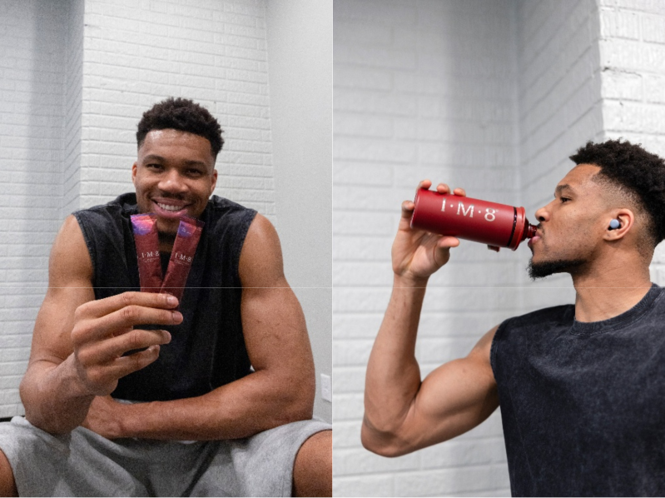

The partnership unites one of the most dominant and beloved athletes in professional sports with the fastest-growing supplement brand ever recorded. Since launching in December 2024, IM8 reached $100 million in annualized recurring revenue within just 11 months, a pace unprecedented in the supplement industry. Today, IM8 has delivered more than 22 million servings, and reached more than 750,000 customer purchases across 31 countries, and is projected to generate approximately $180 million to $200 million in full year revenue in 2026.

Antetokounmpo commands over 35 million followers across his social platforms, including Instagram, X, and TikTok, with particular strength in the United States, Europe, Africa, and Asia, geographies that align

directly with IM8’s global expansion roadmap. The NBA is broadcast in over 215 countries and territories, providing IM8 with a direct channel into markets the brand has not yet activated at scale.

Danny Yeung, CEO of Prenetics and co-founder of IM8, commented, “David Beckham co-founded IM8. Aryna Sabalenka and Ollie Bearman took equity. And now Giannis — because he represents everything IM8 stands for: relentless discipline, authenticity, and an unwillingness to cut corners. The fact he chose 100% equity over any cash compensation says more about his belief in what we’re building than any marketing campaign ever could. He's not lending us his name. He's investing in our future.”

Danny added “Four sports. Four of the most respected athletes on the planet. More than 200 million followers combined. Every one of them chose to become a shareholder. No other brand in this industry has that – and with approximately $160 million in liquidity, zero debt, and a clear path to profitability, we have the roster and the capital to match the conviction. We’re building a generational brand in consumer health, and rewarding every shareholder and partner building it with us.”

Giannis Antetokounmpo said “I’m very careful about what I put in my body and what I put my name on. For me, taking care of my body isn’t just about basketball — it’s about how I live every day. When I started taking IM8, I noticed the difference and it quickly became part of my daily routine. It’s something that helps support my energy, recovery, and overall health so I can be at my best, both on and off the court. As I kept using it, I wanted to learn more about the people behind it. I spent time getting to know the team and saw how serious they are about the science, the ingredients, and building something real in health and performance. That’s what made me want to be part of what they’re building and support the brand as a shareholder.”

Why This Partnership Matters

For Prenetics shareholders, the Antetokounmpo partnership addresses three strategic priorities.

First, it expands IM8’s addressable market. Antetokounmpo’s core audience skews 18–34, a demographic where IM8 is currently under-scaled. The NBA is broadcast in over 215 countries and territories. This partnership gives IM8 a direct channel into markets the brand has not yet activated at scale, at a time when the Company is targeting $180 million to $200 million in IM8 revenue for fiscal year 2026.

Second, it deepens IM8’s cross-sport credibility. Football, Tennis, Formula 1, and now Basketball. Four sports. Four equity holders. No other supplement brand has assembled a roster of this caliber, or this structure. For consumers, it answers the question of product quality before it is asked.

Third, it reinforces structural alignment between the Company and its partners. When Antetokounmpo joins as a shareholder, he is making the same bet Prenetics management has made with up to $42.75 million in combined corporate and personal share commitments, including the up to $40 million share repurchase program and $2.75 million in recent executive open-market purchases. The Company’s total adjusted liquidity¹ stands at approximately $160 million on a zero-debt basis as of March 1, 2026, with adjusted EBITDA profitability targeted by Q4 2027.

IM8: The Product Behind the Conviction

- Adjusted liquidity is a non-IFRS financial measure, comprising: cash and cash equivalents of $93.0 million, financial assets at fair value through profit or loss (primarily comprising of fixed income funds) of approximately $29.3 million based on the most recent available valuation and subject to finalization as part of the ongoing annual audit, digital asset holdings valued at approximately $34.2 million, and portions of gross proceeds of the ACT Genomics sale and Insighta sale transactions held in escrow pending fulfillment of customary release conditions of $6.3 million and $1.0 million, respectively. Our total adjusted liquidity decreased from approximately $171 million as of February 15, 2026 to approximately $164 million as of March 1, 2026 on account of expenses used to support inventory growth and marketing costs on advertising services.

IM8’s flagship product, Daily Ultimate Essentials PRO, delivers 90 premium ingredients at clinical doses in a single daily serving. The brand’s second pillar, Daily Ultimate Longevity, targets the 12 hallmarks of aging with 10 key compounds, offering a science-backed approach to cellular health and healthy aging. Both products can be combined as the Beckham Stack, a complete daily protocol.

IM8’s formulations are NSF Certified for Sport and backed by a 12-week randomized controlled trial conducted by the San Francisco Research Institute, with results showing significant improvements across energy, digestion, sleep, and focus. The Company expects to initiate multiple new clinical trials in 2026, with results anticipated by year-end.

For Giannis media files, please find it here: https://im8health.com/pages/press

About Prenetics

Prenetics (NASDAQ: PRE) is a leading health sciences company dedicated to advancing human health and longevity. The Company’s flagship consumer brand, IM8, co-founded with David Beckham and trusted by NBA superstar, Giannis Antetokounmpo, World No. 1 tennis player Aryna Sabalenka and F1 phenom Ollie Bearman, is redefining the premium daily nutrition category through science-backed formulations and global brand partnerships. Since its launch, IM8 has become one of the fastest-growing brands in consumer health, achieving an impressive milestone of surpassing $100 million in annualized recurring revenue within just 11 months of operations, and is now sold in more than 30 countries worldwide.

About IM8

IM8 is the pinnacle of premium core nutrition, born from a collaboration between David Beckham as a co-founding partner, and an elite team of scientists spanning medical professionals, academia and space science. Combining cutting-edge science with nature’s most potent ingredients, IM8 delivers a holistic, science-backed approach to health, empowering you to live your most vibrant life. IM8’s flagship product, Daily Ultimate Essentials is an all-in-one powder supplement engineered to replace 16 different supplements in a delicious drink and is NSF Certified for Sport, non-GMO, vegan, free from common allergens, and contains no artificial flavors, colors or sweeteners. IM8 is a subsidiary of Prenetics (NASDAQ: PRE), a leading global health sciences company dedicated to advancing consumer health. To learn more about IM8, please visit www.IM8health.com.

About Giannis Antetokounmpo

Antetokounmpo’s journey from Sepolia, Athens to NBA Champion is one of the most compelling stories in professional sports. The son of Nigerian immigrants who sold goods on the streets of Athens to support his family, Giannis built his career on discipline, authenticity, and an extraordinary work ethic. He has earned two NBA MVP awards (2019, 2020), an NBA Championship and Finals MVP (2021), Defensive Player of the Year (2020), NBA Cup MVP (2024), and was named to the NBA 75th Anniversary Team.

Investor Relations Contact

investors@prenetics.com

PRE@mzgroup.us

Angela Cheung

Investor Relations / Corporate Finance

angela.hm.cheung@prenetics.com

Forward-Looking Statements

This press release contains forward-looking statements. These statements are made under the “safe harbor” provisions of the U.S. Private Securities Litigation Reform Act of 1995. Statements that are not historical facts, including statements about the Company’s goals, targets, projections, outlooks, beliefs, expectations, strategy, plans, objectives of management for future operations of the Company, and growth opportunities are forward-looking statements. Our guidance reflects management’s current estimates and assumptions as of the date of this release, is subject to significant risks and uncertainties, and is not a guarantee of future performance. Actual results may differ materially. In some cases, forward-looking statements can be identified by words or phrases such as “may,” “will,” “expect,” “anticipate,” “target,” “aim,” “estimate,” “intend,” “plan,” “believe,” “potential,” “continue,” “is/are likely to,” “guidance,” “outlook,” “forecast,” or other similar expressions. Forward-looking statements are based upon estimates and forecasts and reflect the views, assumptions, expectations, and opinions of the Company, which involve inherent risks and uncertainties, and therefore they should not be relied upon as being necessarily indicative of future results. A number of factors could cause actual results to differ materially from those contained in any forward-looking statement, including but not limited to: the Company’s purchase of digital asset subjects it to risks related to extreme volatility and speculative nature of digital asset; the Company may not be able to maintain and enhance its IM8 business and brand if it suffers negative publicity or fails to maintain a strong base of engaged customers and content creators, or otherwise fails to meet customers’ expectations; the Company’s ability to further develop and grow its business, including new products and services; and its ability to identify and execute on M&A opportunities. In addition to the foregoing factors, you should also carefully consider the other risks and uncertainties described in the “Risk Factors” section of the Company’s most recent registration statement and the prospectus therein, and the other documents filed by the Company from time to time with the U.S. Securities and Exchange Commission. Unless otherwise specified, all information provided in this press release is as of the date of this press release, and the Company does not undertake any duty to update such information, except as required under applicable law.

